Main Publications (thematic)

Gesture-controled voice instruments
- Christophe d'Alessandro, Albert Rilliard, and Sylvain Le Beux "Chironomic stylization of intonation" J. Acoust. Soc. Am., 129(3), march 2011, 1594-1604.
- N. D'Alessandro, B. Doval, C. d'Alessandro, S. Le Beux, P. Woodruff, Y. Fabre, T. Dutoit « RAMCESS: Realtime and Accurate Musical Control of Expression in Singing Synthesis », Journal on Multimodal User Interfaces, Vol. 1, No. 1, March 2007, p 31-39.39.
- Lionel Feugère, Sylvain Le Beux, Christophe d’Alessandro, « Chorus Digitalis : polyphonic gestural singing », In Proceedings of the 1st International Workshop on Performative Speech and Singing Synthesis (p3s), Vancouver, , 14-15 mars 2011.
- Sylvain Le Beux, Lionel Feugère, Christophe d’Alessandro, « Chrous Digitalis : experiment in chironomic choir singing » Proc. Interspeech 2011. 12th Annual Conference of the International Speech Communication Association.

pipe organs: organology, live electronics
- Christophe d’Alessandro, Markus Noisternig, (2011) “Orgue : intérieur/extérieur” , SIMULATION TECHNOLOGIQUE ET MATÉRIALISATION ARTISTIQUE, Une exploration transdisciplinaire arts/sciences, Samuel Bianchini, Nathalie Delprat, Christian Jacquemin(Eds), L'Harmattan, ISBN : 978-2-296-55938-7, janvier 2012.
- C. d’Alessandro , “Orgues, musiques et musiciens à Sainte-Élisabeth», monographie, « la Flûte Harmonique », n°91, 2011, 224 pages.
- C. Jacquemin, R. Ajaj, S. Le Beux, C. d’Alessandro, M. Noisternig, B.F.G. Katz, and B. Planes, (2010) « Organ Augmented Reality: Audio−Graphical Augmentation of a Classical Instrument », Int. J. of Creative Interfaces and Computer Graphics (IJCICG), ISSN: 1947−3117, vol. 1 N° 2, 51−66.50.
- Christophe d’Alessando, Markus Noisternig, Sylvain Le Beux, Lorenzo Picinali, Brian Katz, Christian Jacquemin, Rami Ajaj, Bertrand Planes, Nicolas Strurmel, Nathalie Delprat « the ORA Project: audio-visual live electronics and the pipe organ », proceedings of International Computer Music Conference, ICMC 2009, Montréal, Canada. ISBN : 0-9713192-7-8, p477-480
- C.d'Alessandro. « SURET, facteur de grandes orgues d'église, et d'orgues d'accompagnement pour les choeurs. » L'Orgue Francophone, 16: p. 38-63, 1999. FFAO.
- C.d'Alessandro. « L'orgue de Sainte-Elisabeth ». Orgues en Ile-de-France, numéro hors série, L'Orgue Francophone, .p. 50-52, 1999. FFAO.

Voice quality, voice source analysis
- Sevasti-Zoi Karakozoglou, Nathalie Henrich, Christophe d’Alessandro, Yaniis Stylianou, « Automatic glottal segmentation using local-based active contours and application to glottovibrography », Speech Communication, (online 09/2011, printed version forthoming)
- B. Doval, C. d’Alessandro, N. Henrich, "The spectrum of glottal flow models" Acta Acustica united with Acustica, vol 92, No6, November-december, 2006 p. 1226-1246.
- B. Bozkurt, B. Doval, C. D’Alessandro, and T. Dutoit, "Zeros of Z-Transform Representation With Application to Source-Filter Separation in Speech" IEEE Signal Processing Letters, Vol. 12, No. 4, April 2005, p 344-347.
- D. Sciamarella, C. d'Alessandro "On the Acoustic Sensitivity of a Symmetrical Two-Mass Model of the Vocal Fold to the Variation of Control Parameters”, Acta Acustica united with Acustica, 90, 2004, p 746-761.
- N. Henrich, C. d'Alessandro, M. Castellengo and B. Doval "On the use of the derivative of elecroglottographic signals for characterization of non pathological phonation", Journal of the Acoustical Society of America 115(3), mars 2004, p1321-1332.
- C.d'Alessandro, V.Darsinos, and B.Yegnanarayana. “Effectiveness of a periodic and aperiodic decomposition method for analysis of voice sources”. IEEE transaction on Speech and Audio Processing, 6(1): 1998, p. 12-23.
- B.Yegnanarayana, C.d'Alessandro, and V.Darsinos. “An iterative algorithm for decomposition of speech signals into periodic and aperiodic components”. IEEE transaction on Speech and Audio Processing, 6(1): 1998, p. 1-11.
- G.Richard and C.d'Alessandro. “Analysis/synthesis and modification of the speech aperiodic component”. Speech Communication, 19, 1996, p. 221-244.
- C.d'Alessandro and P.Mertens. “Automatic pitch contour stylization using a model of tonal perception”. Computer Speech and Language, 9(3): 1995, p. 257-288.

Text to speech synthesis
- C d'Alessandro, P. Boula De Mareuil, R. Prudon, « Synthèse par sélection : prosodie, dialogue et qualité vocale ». Cahiers de l'Institut de Linguistique de Louvain, Vol.30, n°1-3, 2004, p. 153-180.
- - P. Boula de Mareüil, C. d'Alessandro, F. Beaugendre, A. Lacheret-Dujour. « Une grammaire en tronçons appliquée à la génération de la prosodie ». Traitement Automatique des Langues (TAL), Hermès, Vol. 42 No 1, 2001, p. 115-143.
- C. d'Alessandro. « 33 ans de synthèse de la parole à partir du texte: une promenade sonore (1968-2001) ». Traitement Automatique des Langues (TAL), Hermès, Vol. 42 No 1 (avec un disque compact audio de 62 mn), 2001, p. 297-321.
- C. d'Alessandro, E. Tzoukermann (Editors), « Synthèse de la parole à partir du texte. » Traitement Automatique des Langues , Hermès, Vol. 42 No 1, 333 pages + disque compact audio de 62 mn, ISBN 2-7462-0344-8, 2001.
- F.Yvon, P. Boula de Mareüil, C. d'Alessandro, V. Aubergé, M. Bagein, G. Bailly, F. Béchet, S. Foukia, J.-P. Goldman, E. Keller, V. Pagel, F. Sannier, J. Véronis, D. O'Shaughnessy, B. Zellner. “Objective evaluation of grapheme to phoneme conversion for Text-To-Speech synthesis in French.” Computer Speech and Language, 12(4): 1998, p 393-410.
- B. Bozkurt, T. Dutoit, R. Prudon, C. D’Alessandro, V. Pagel ”Reducing discontinuities at synthesis time for corpus-based speech synthesis” in Shri Narayanan and Abeer Alwan (Eds) “Text to Speech Synthesis: New Paradigms and Advances”, Chapitre 1, Prentice Hall, ISBN: 013145661X; juillet 2004, p. 1-17.
- R.Prudon, P. Boula de Mareüil, C. d’Alessandro, “Unit Selection Synthesis of Prosody: Evaluation Using Diphone Transplantation”, in Shri Narayanan and Abeer Alwan (Eds) “Text to Speech Synthesis: New Paradigms and Advances” Chapitre 9, Prentice Hall, ISBN: 013145661X; juillet 2004, p. 203-217
- C. d'Alessandro. L’évaluation des systèmes de synthèse la parole. In S. Chaudiron, éditeur, "Evaluation des systèmes de traitement de l’information``, Hermès, ISBN: 2-7462-0862-8, 2004, pp 215-239.

wavelets, ZZT,and signal processing
- Christophe d’Alessandro Nicolas Sturmel, “Glottal Closure Instant and Voice Source Analysis using Time−Scale Lines of Maximum Amplitude », Sadhana − Academy Proceedings in Engineering Sciences, Indian academy of science,Springer, ISSN: 0256−2499, Vol. 36, Part 5, pp. 601–622, October 2011.
- B. Bozkurt, B. Doval, C. D’Alessandro, and T. Dutoit, "Zeros of Z-Transform Representation With Application to Source-Filter Separation in Speech" IEEE Signal Processing Letters, Vol. 12, No. 4, April 2005, p 344-347.
- C.d'Alessandro and C.Demars. « Représentations temps-fréquence du signal de parole. » Traitement du Signal, 9(2): 1992, p. 153-173.
- C.d'Alessandro. “Time-frequency speech transformation based on an elementary waveform representation”. Speech Communication, 9(5-6): 1990, p. 419-431.
- C.d'Alessandro. “Time-frequency speech transformation based on an elementary waveform representation”. Speech Communication, 9(5-6): 1990, p. 419-431.
- C.d'Alessandro and X.Rodet. « Synthèse et analyse-synthèse par fonctions d'ondes formantiques ». Journal d'Acoustique, 2: 1989, p. 163-169.

Intonation perception and modeling
- C.d'Alessandro, S.Rosset and J.P. Rossi. “The pitch of short-duration fundamental frequency glissandos”. Journal of the Acoustical Society of America, 104(4): 1998, p 2339-2348.
- C.d'Alessandro and P.Mertens. “Automatic pitch contour stylization using a model of tonal perception”. Computer Speech and Language, 9(3): 1995, p. 257-288.

Singing voice
- N. Henrich, C. d'Alessandro, B. Doval, and M. Castellengo “Glottal open quotient in singing: Measurements and correlation with laryngeal mechanisms, vocal intensity, and fundamental frequency” Journal of the acoustical Society of America 117(3), mars 2005, p1417-1430.
- C.d'Alessandro and M.Castellengo. “The pitch of short-duration vibrato tones”. Journal of the Acoustical Society of America, 95(3): 1994, p. 1617-1630.
- N. Henrich, G. Sundin, D. Ambroise, C. d'Alessandro, M. Castellengo, B. Doval. “Just noticeable differences of open quotient and asymmetry coefficient in singing voice”. Journal of Voice, vol 17(4), dec. 2003, p. 481-494.
- C.d'Alessandro, P.Depalle, and X.Rodet. « Machines à chanter ». Résonance, 8: p. 8-13, 1995. IRCAM-Centre Pompidou.

Acoustics of the clavichord
- Christophe d’Alessandro "On the dynamics of the clavichord: From tangent motion to sound" J. Acoust. Soc. Am., volume 128, No. 4, October 2010, pp. 2173−2181.
- Christophe d’Alessandro (2010) « The acoustics of tangent-string interaction in the clavichord compared to hammer-string interaction in the fortepiano” De Clavicordio, XI, B. Brauchli, A. Galazzo, J. Wardman, eds. ISBN 978-88-900269-5-9.
- Christophe d’Alessandro, Charles Besnainou, Luc Ginieis (2008) « Acoustic portrait of four clavichords : tangent velocities, loudness and decay times » De Clavicordio, VIII, B. Brauchli, A. Galazzo, J. Wardman, eds. ISBN 978-88-900269-5-9, p201-213
- C. d’Alessandro, B.F.G. Katz, F. Boudet « On the acoustics of the clavichord » in De Clavicordio VII, 2006, pp. 171-182.
- C. d'Alessandro, B. F.G. Katz, “Tonal quality of the clavichord: the effect of sympathetic strings”, proceedings of . International Symposium on Musical Acoustics, ISMA 2004, Nara, Japon, ISBN4-9980602-2-8, 1-P1-7, avril 2004, 4 pages.

Organized conferences
- 2011 : DAFx 2011, 14th International Conference on Digital Audio Effects, September 19-23, 2011 Paris, France, Local Scientific Commitee
- 2008 : Enterface'08, international workshop, 4-29 august 2008, LIMSI, Orsay, chairman
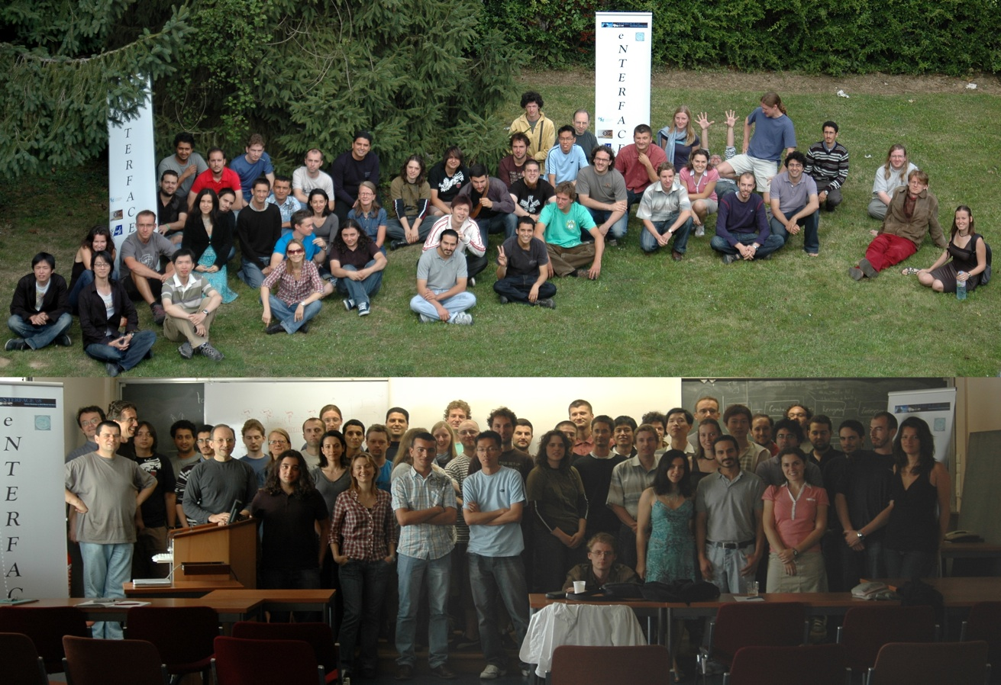
- 2007 : ParaLing'07. International workshop on Paralinguistic Speech - between models and data, Saarbruecken, co-chairman, with Mark Schröder and Anton Batliner.
- 2005 : "Speech conductor" project, international workshop Enterface'05 (NoE SIMILAR), project leader, Mons, July 2005.
- 2003 : ISCA International Tutorial and Research Workshop "Voice Quality : functions, analysis and synthesis ", Genève. Chairman, with Klaus Scherer, and Nick Campbel.
- 1998 : Colloque "Acoustique et instruments anciens", Musée de la Musique, cité de la Musique, Paris, 18-18 novembre 1998, organizing committee.
- 1995 :International Symposium on Musical Acoustics, Dourdan, organizing committee.

