New CD
CD Recording Edition Hortus 096, 2012
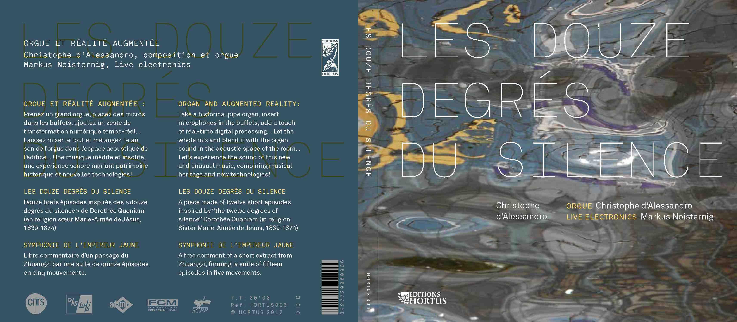 CD Recording Edition Hortus 096, 2012

Music Biography
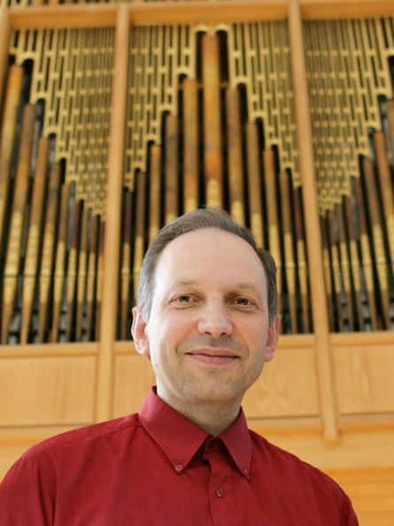
Christophe d'Alessandro (born in Marseille on 16 December 1961) began studying piano in 1968, with Lucien Pipereaut. From 1977 he studied harpsichord and early music with Richard Siegel and Guy Robert, then organ and improvisation with Suzanne Chaisemartin and Denys Mathieu-Chiquet, and played keyboards in various rock bands and free-jazz groups. Christophe d'Alessandro studied composition with Luc Ferrari, harmony, counterpoint and analysis with Jean-Michel Bardez and Solange Ancona. His early interest in musical creation and research lead him to study mathematics and computer science. He joined the CNRS in 1989, where he is currently Director of Research, Head of the Audio & Acoustics group at LIMSI-CNRS. He has published many works on the analysis and synthesis of voice, speech, organology, instrumental gesture, and computer music. Appointed assistant organist in 1988 and titular organist in 1992 at Sainte-Elisabeth, Christophe d'Alessandro is regularly invited as a performer and improviser, and has recorded for radio and television programmes. He is a member of the Historic Organ Committee of the French Ministry of Culture. Christophe d’Alessandro’s music is influenced by his works on language and gestures: vocalic colours and timbres, speech prosody, consonantal rhythms.
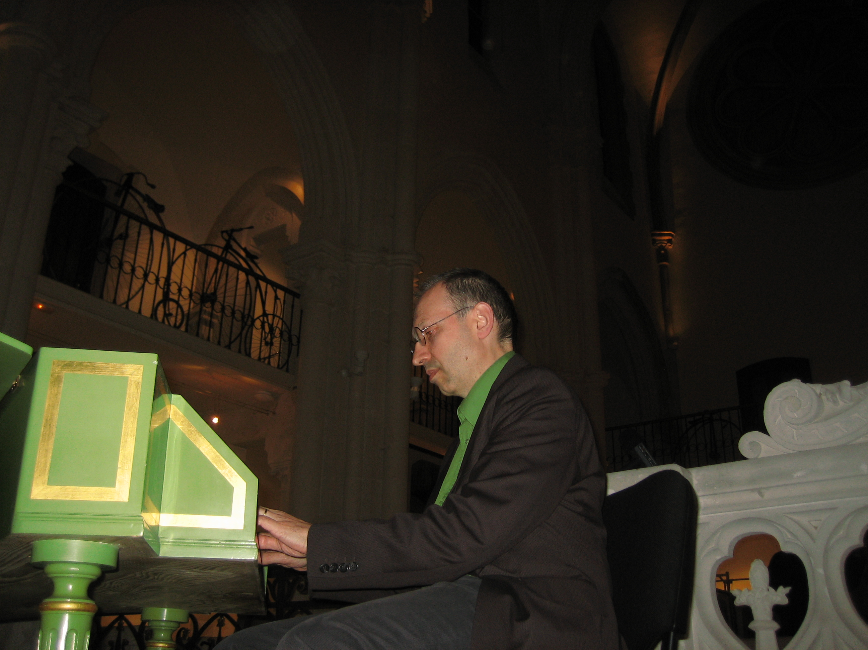

Sainte Élisabeth organ
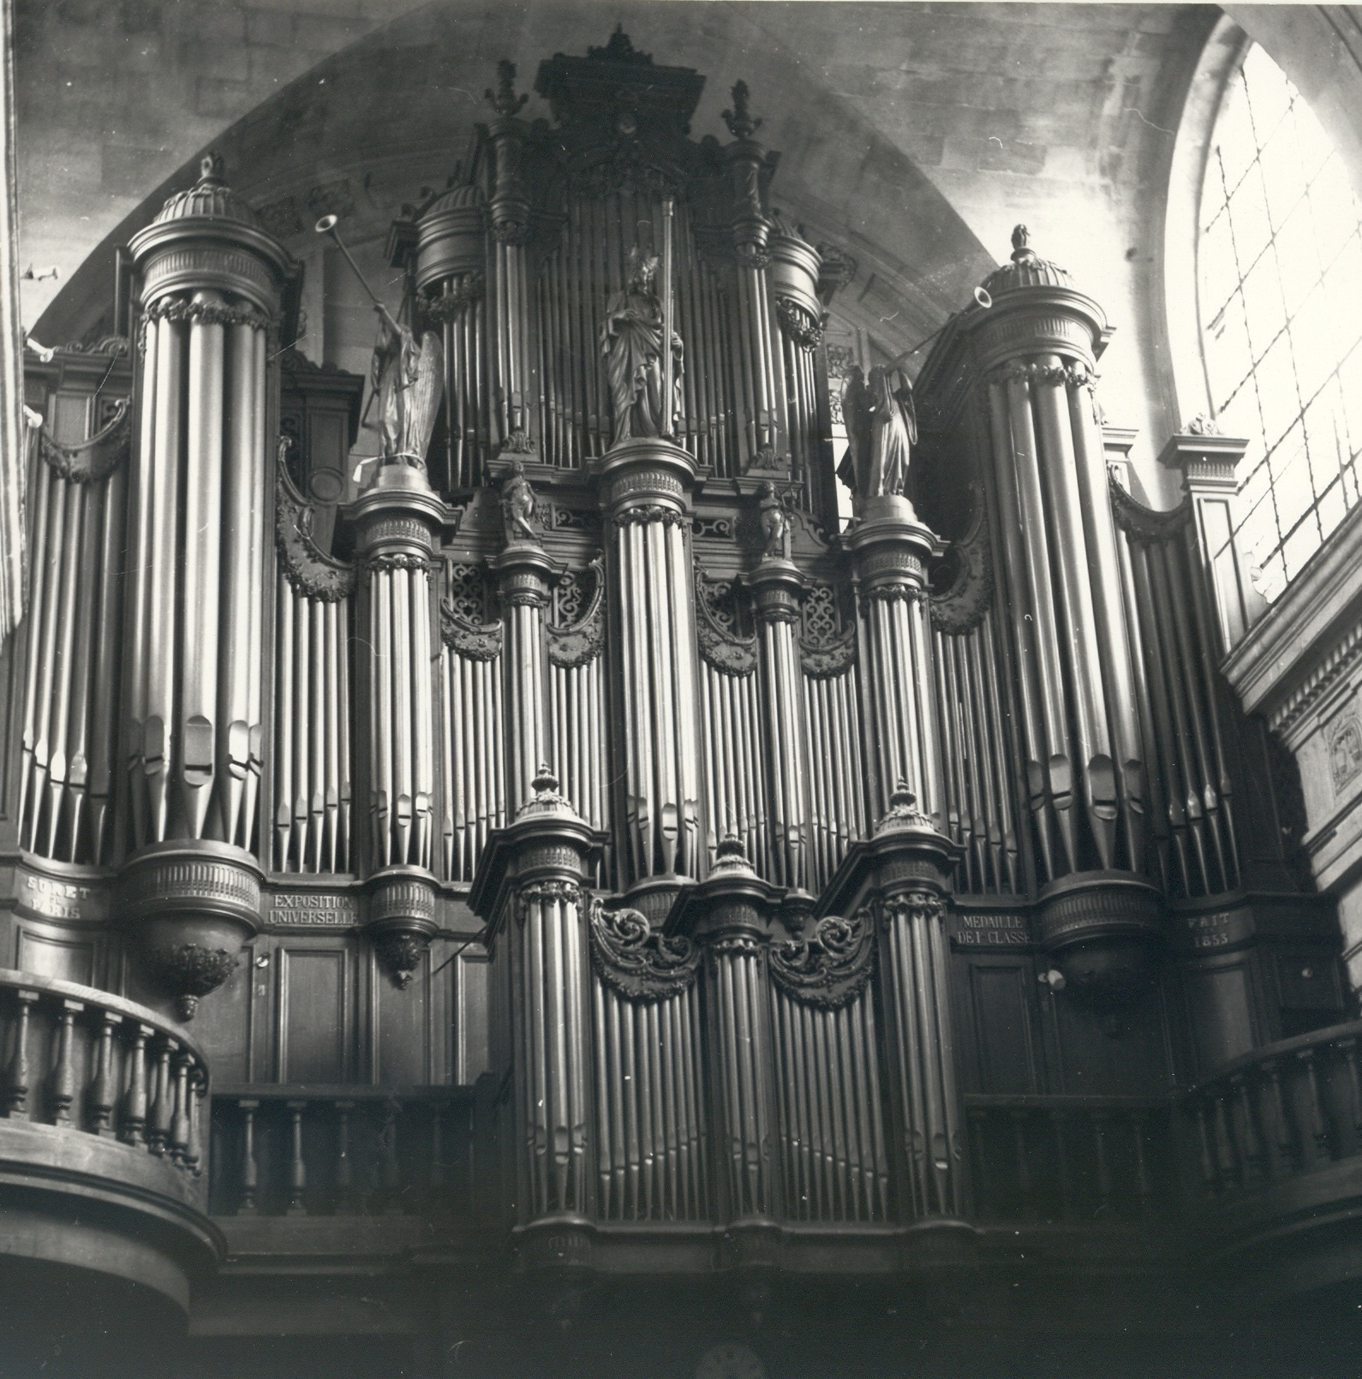

The Church
St. Elisabeth church was built in two seperate eras. The initial one dates from the first half of the 17th century and was built to house nuns under the protection of Our Lady of Mercy and St. Elisabeth of Hungary. These nuns are from the third order of St. Francis, that explains the protection of St. Elisabeth of Hungary.
Used as a storage during the Revolution, the church's role is modified in the first half of the 19th century: it became a parish church in the Temple district. The convent is demolished, the chapel building is modified very consequently and takes the shape we know today.
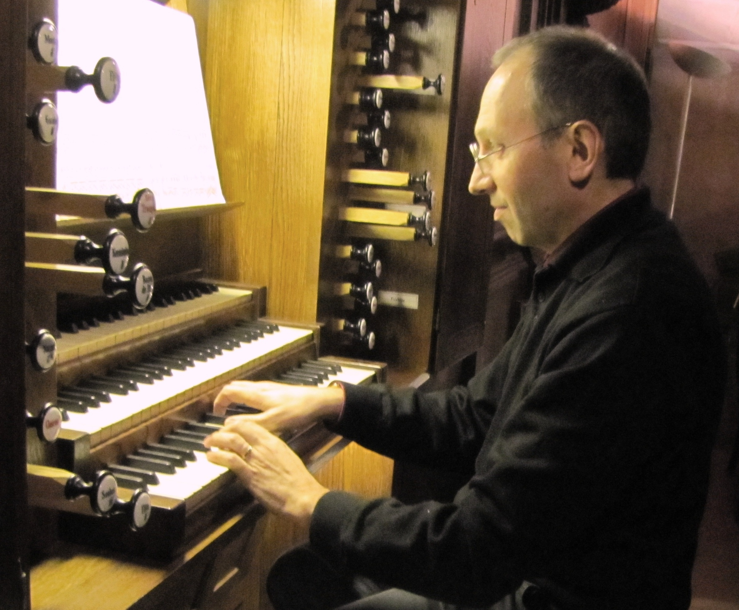

The Organ
Organbuilders brothers Claude installed, in 1845-6, a new instrument in the newly built gallery in the rear of the church. It is an 8-foot instrument with 20 stops over 3 manuals and pedal. This instrument, with its cone-valve chest, must have been of poor quality because, barely five years later, Marie-Antoine-Louis Suret is called in to replace it. However, it is probable that the central section of the actual main organcase is the Claude's old organcase. The outstanding organcase was classified as an "historic landmark" on February 20, 1905.
In 1852-53, Marie-Antoine-Louis Suret and his son, Marie-François-Auguste, will build their largest instrument that will also be their masterpiece. The large 16-foot instrument originally had 36 stops over 3 manuals and pedal. This instrument, designed on large dimensions, has the advantage of being located in a monumental three-storey organcase, made of fir and painted imitation oak, with its twelve turrets and its sumptuous sculptures fills the end of the nave. The Positif organcase with its three turrets is supported by culs-de-lampe and is topped by a frieze and a cornice on which flower garlands form festoons that hangs over the top of the pipework. The large two-storey main organcase takes up the whole width of the nave; the turrets of the first storey are topped with wooden statues. On the occasion of the industrial product fair of 1855, a gold medal was awarded, to Suret, for the instrument in St. Elisabeth.
The instrument was inaugurated on April 28, 1853 by organists Louis-Alfred-James Lefébure-Wély, Alexandre-Charles Fessy, and the titular of the instrument, Auguste Bazille.
During the 30's and 40's, many restoration projects were presented. They all praise the quality of the instrument but they criticize its old-fashioned aesthetics and deplore its hard nearly centennial mechanical action. G. Gutschenritter's 1941 project was delayed due to World War II but is finally carried out after the war, between 1955 and 1959. The Suret-Gutchenritter oran was received on January 22, 1959 by the City of Paris. The inconsistency of the restoration project and the poor quality of the workmanship leads to a quick deterioration of the instrument but it awakens interest for Suret's instrumental structure which is classified as "historical landmark" on January 18, 1980.
In 1991, a second restoration, in fact a complete "de-restoration", is approved by the Historic Monuments Commission. Works, equally financed by the City of Paris and the State, are commissionned to organbuilding firm Giroud and are carried out between 1994 and 1999. Jacques Nonnet supervises the project and carries out the voicing of the instrument. The Suret-Giroud instrument is received on January 21, 1999. It was blessed, on May 3, 1999, by Bishop Pierre d'Ornelas, auxiliary bishop of Paris. The inauguration took place on October 20, 1999 with the participation of organists François-Henri Houbard, Olivier Trachier, Denys Mathieu-Chiquet, and the titular of the instrument, Christophe d'Alessandro.
The present instrument contains all the innovations of the Parisian Romanesque organbuilding techniques from the first half of the 19th century, with the exception of the Barker machine. Pipework is cut to length except for a few late-developped stops of the Récit. The differences between the Suret-Giroud organ and the original Suret organ are minor: a 5-rank Plein jeu replaces the Euphone, melted in 1955; free reed stops have been reconstructed as beating reeds; the console, the framework and the mechanical action vanished or modified in 1955 have been reconstructed. The visitor is always struck by the grandeur of the organcase and the auditor, by the perfect sound of the instrument.
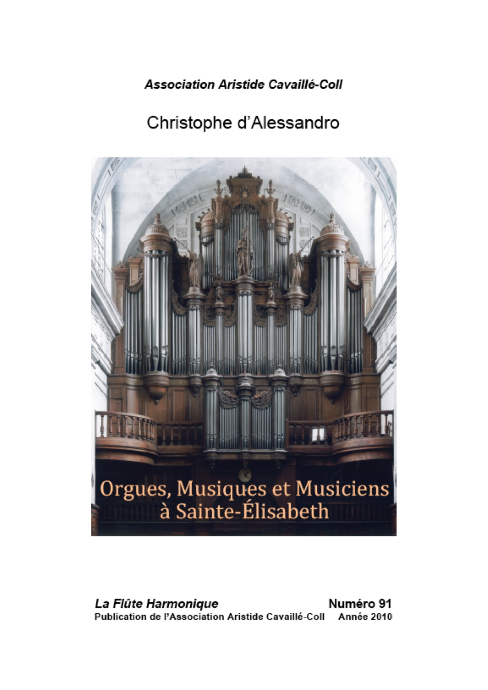
C. d’Alessandro , “Orgues, musiques et musiciens à Sainte-Élisabeth», monographie, « la Flûte Harmonique », n°91, 2011, 224 pages.

Orgue et Réalité Augmentée
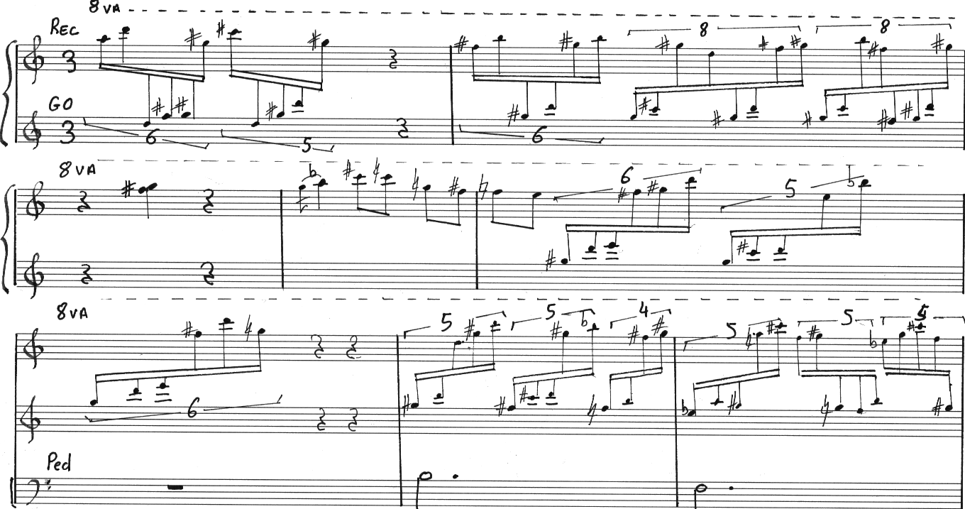

Concert dans le cadre du Festival Le Paris des Orgues, Paris 17/05/2011 : "orgue et réalité augmentée"
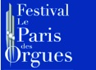

Note de programme
L’orgue est un palimpseste : chaque époque a réutilisé le fond légué par la précédente, et réécrit dessus. La dernière couche est ce soir virtuelle, augmentation numérique : le son interne de l’orgue est capturé, modifié et restitué dans l’espace en temps réel
L’espace acoustique de l’orgue est saturé par le son de ses milliers de tuyaux, et leur infinité, ou presque, de combinaisons. « Augmenter » l’orgue ne peut donc être que transformer l’orgue, changer une partie de son identité, lui donner d’autres comportements : que pourrait-on ajouter à cet instrument déjà presque trop riche ? Augmenter l’orgue revient à l’observer de plus près. Cette observation proximale, intérieure, introspection dans le domaine de l’ouïe, permet de conserver l’instrument tel qu’il nous est parvenu, et de le prolonger, le projeter, le colorer, faire miroiter de nouvelles facettes. Pas de solution de continuité entre l’instrument acoustique et son augmentation numérique, dont le pari est de rester discrète, de disparaître au besoin, de se fondre dans la musique.
Dans cette esthétique du fondu, les effets électroacoustiques se mélangent au son naturel, ouvrent vers un monde sonore fait de micro variations, nuances, tuilages, imitations, intonations fluctuantes, formants mobiles, jeux de mutations artificiels, échos. Une écriture nait de cette symbiose entre le grand orgue et l’électronique, deux mondes sonores en principe hétérogènes.
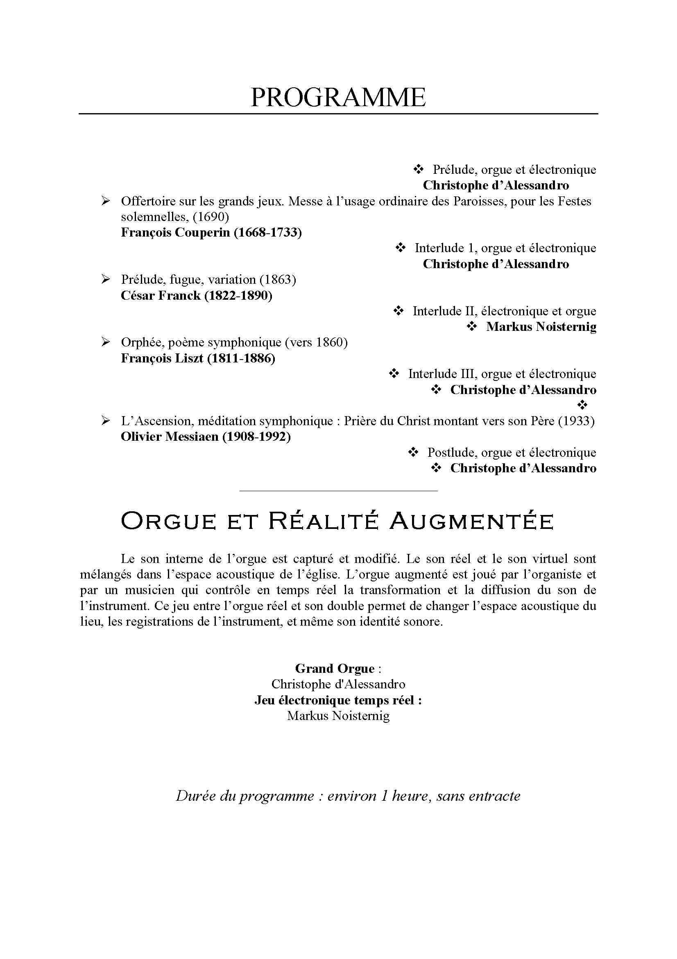

Concert d'ouverture des Journées du Patrimoine Lille 17/9/2010 : "orgue et réalité augmentée"
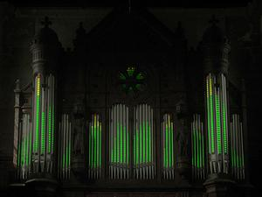Concert d'orgue augmenté - Lille 2010
Le programme « Lille, Ville d'Arts du Futur » et la direction du patrimoine ont proposé le
Vendredi 17 septembre à 20h30 - Eglise Saint-Michel
un concert d'ouverture mêlant orgue et nouvelles technologies !
Prenez un orgue remarquable ; placez-y des micros dans les tuyaux ; ajoutez-y un zeste de vidéoprojection… Laissez mixer le tout par un collectif composé d’artistes et de chercheurs du LIMSI – CNRS… Vous obtiendrez un concert inédit et insolite, une véritable expérience sonore et visuelle alliant arts, patrimoine et nouvelles technologies !
http://wwe.kewego.fr/video/iLyROoafZCEe.html
Orgue et réalité Augmentée conception: C. d'Alessandro, B. Planes, C. Jacquemin, M. Noisternig, Rami Ajaj, Tifanie Bouchara, Emmanuel Blachon
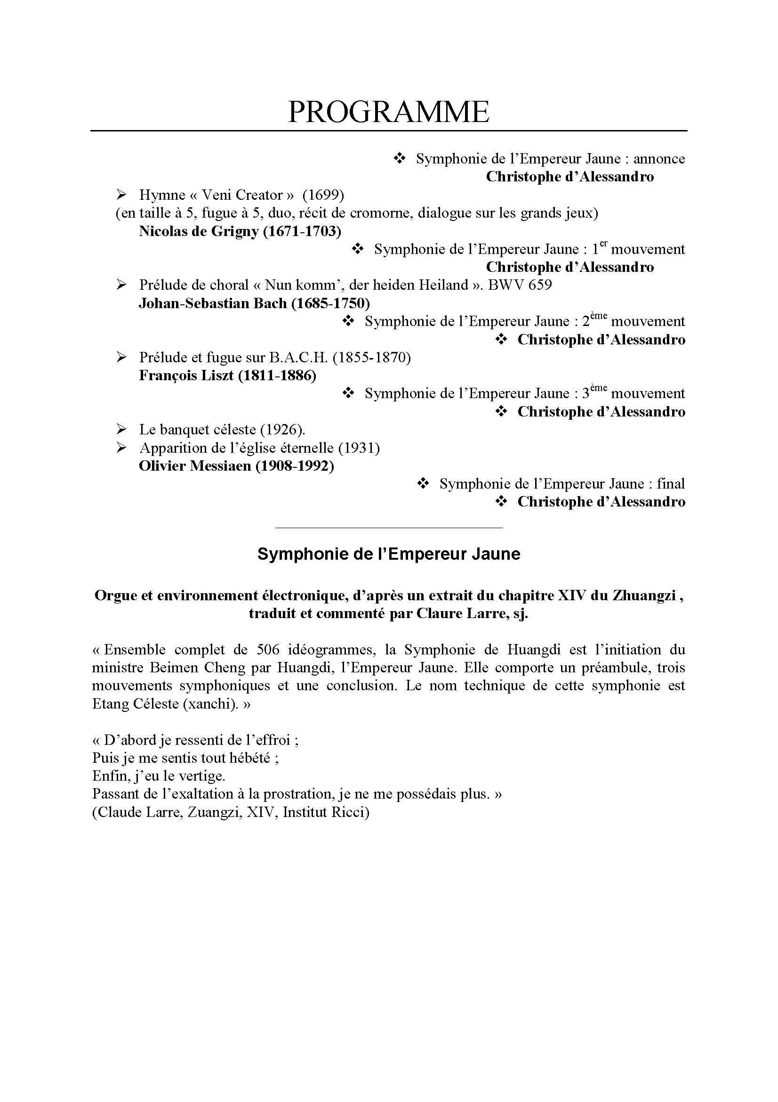
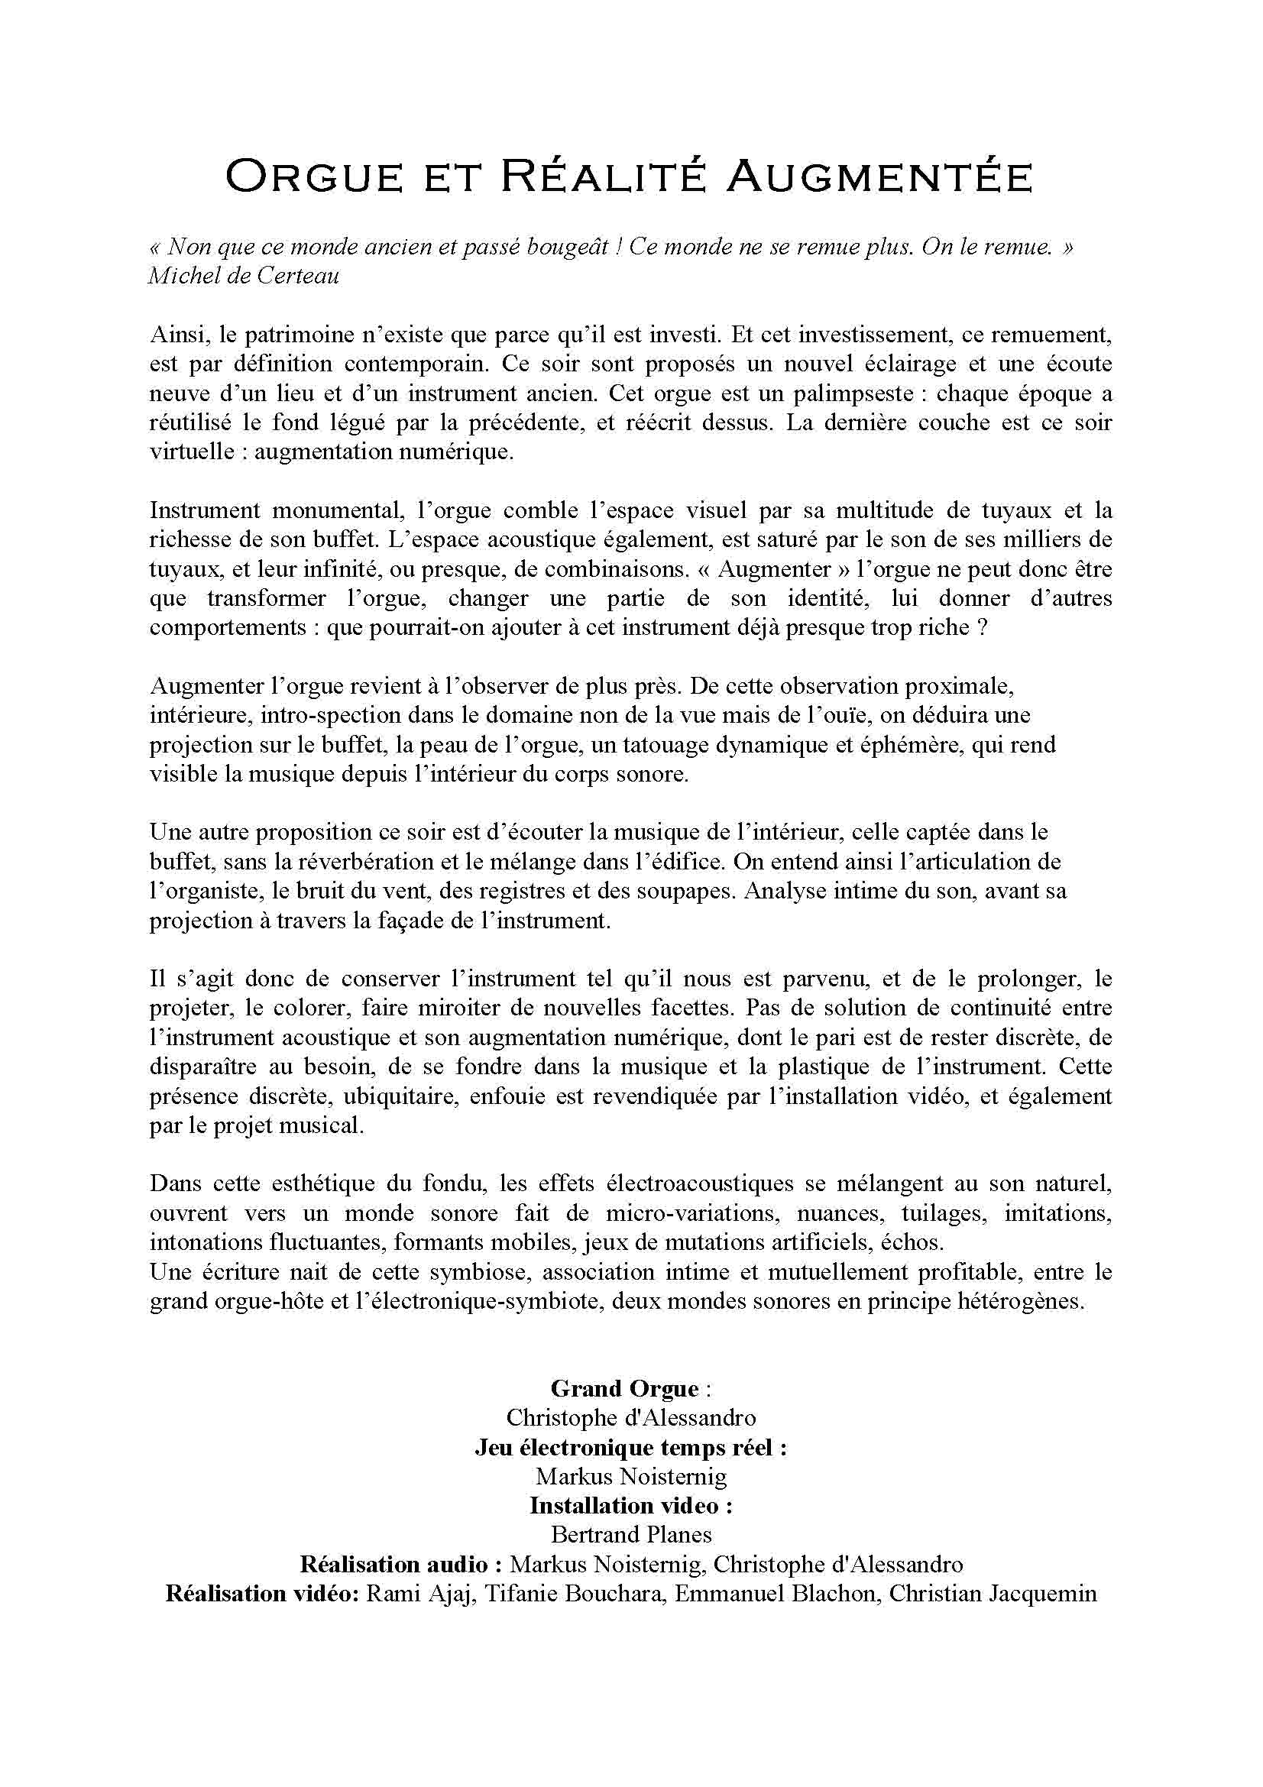

Concerts les 15 et 17 mai 2008 à 21h, Paris, Eglise Sainte Elisabeth
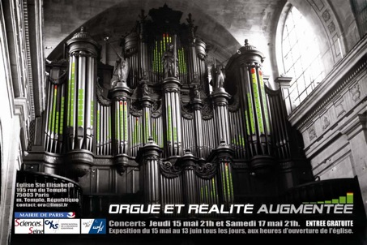
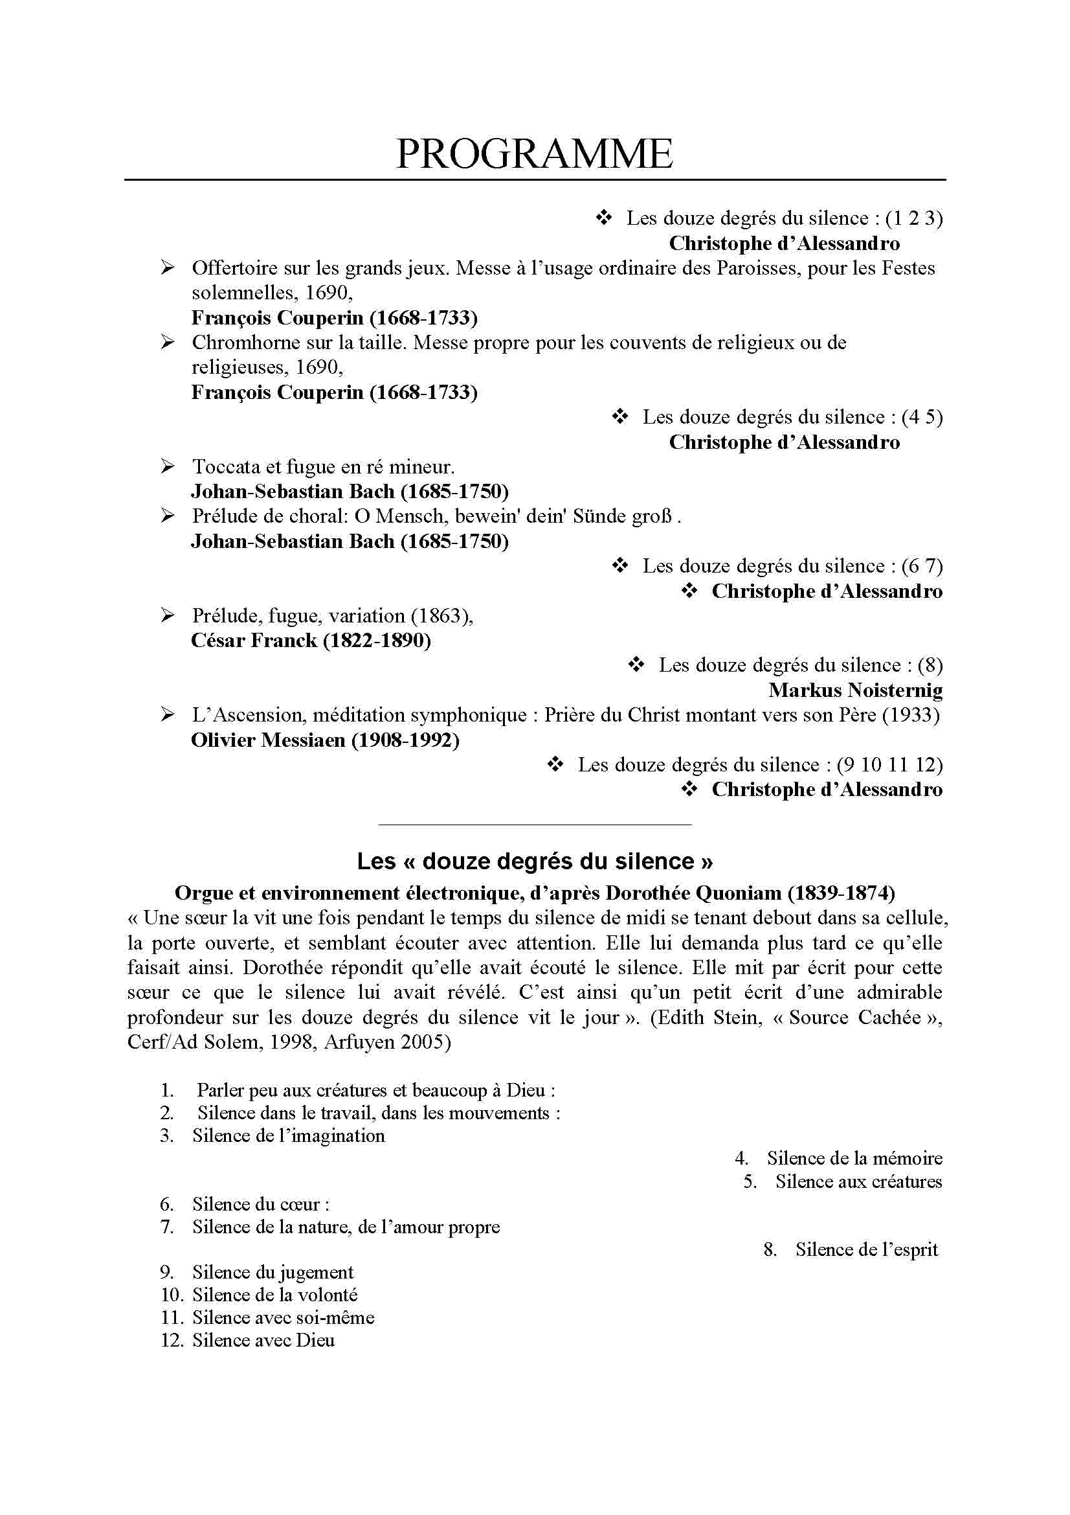
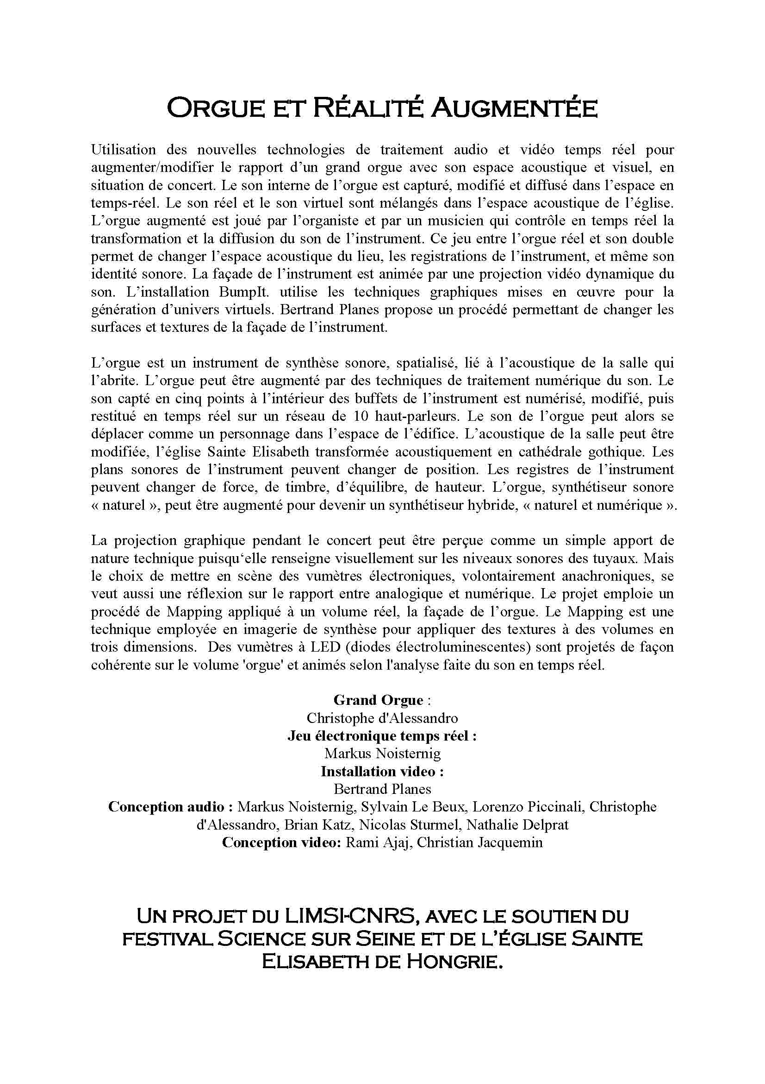
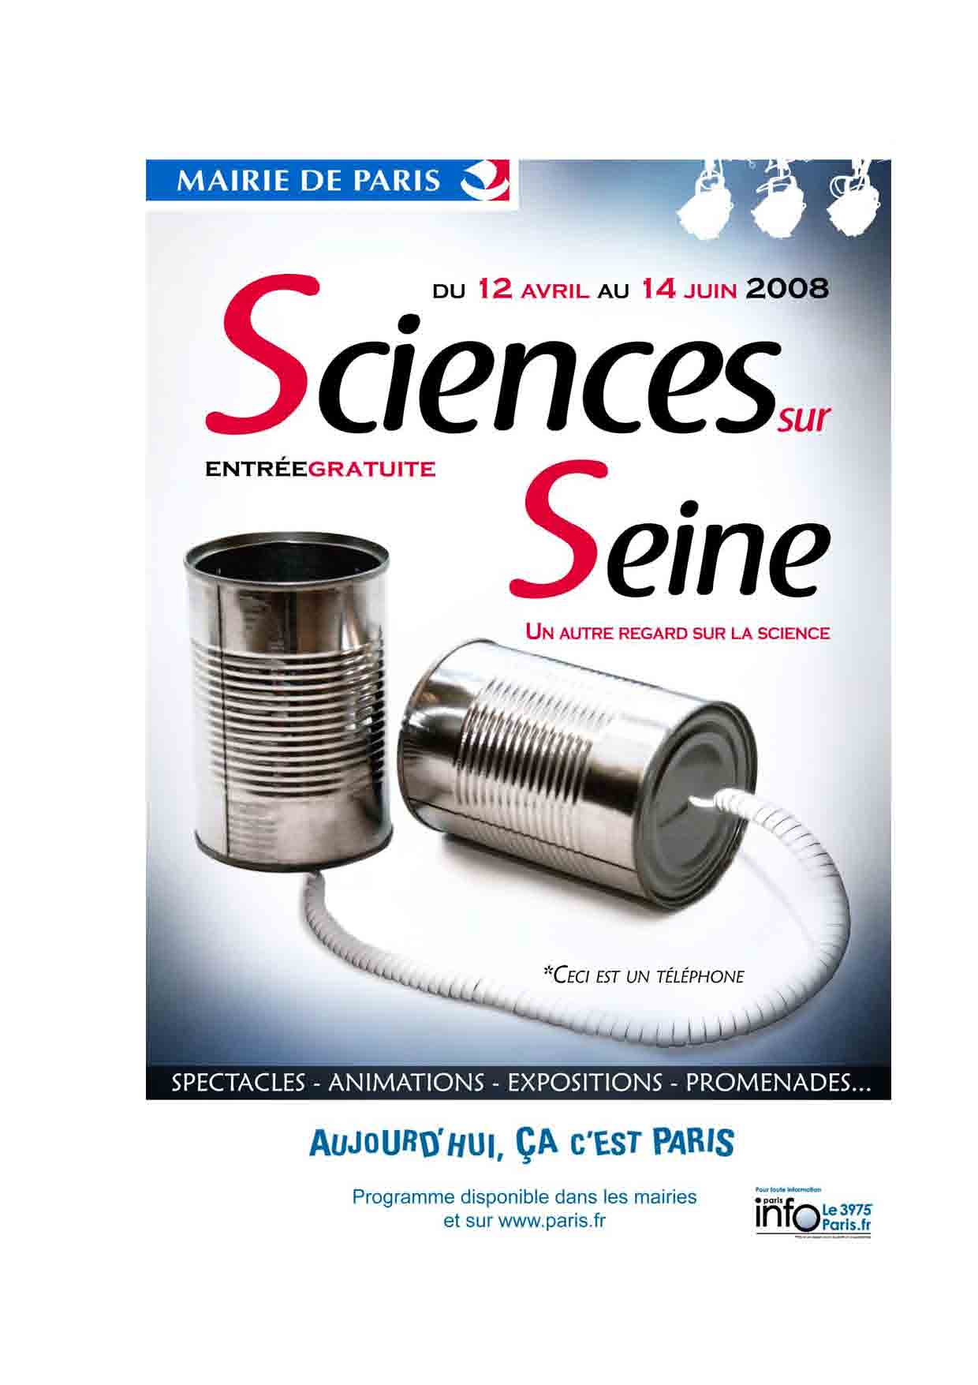

Photos, vidéos, audio
Photos de Christian Jacquemin (jeudi 15 mai 2008)
Photos de Christian Jacquemin (samedi 17 mai 2008)
Vidéo de Christian Jacquemin (samedi 17 mai 2008) (version HD - format DivX) ou Youtube
Vidéos de Nathalie Delprat (making of du projet)
- ORA1_orgue
- ORA2_projet
- ORA3_ essais
- ORA4_concerts
- ORA5_coupées (format Mov)

Chorus Digitalis

Back
membres:cda:

